Price List
Ammo
Nuprol ( 3300 ) 0.20g BB’s £9.00 per bottle
Nuprol ( 3300 ) 0.25g BB’s £11.00 per bottle
Vorsk ( 3300 ) 0.28g BB’s £12.00 per bottle
Nuprol ( 3300 ) 0.30g BB’s £13.00 per bottle
Nuprol ( 3300 ) 0.32g BB’s £14.00 per bottle
Nuprol ( 1000 ) 0.40g BB’s £16.00 per bottle

Tracers
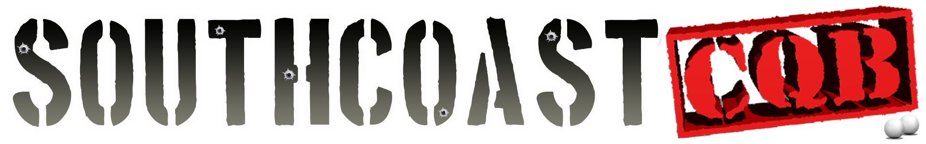
Nuprol ( 3300 ) 0.20g BB’s £12.00 per bottle N/A
Nuprol ( 3300 ) 0.25g BB’s £17.00 per bottle N/A

Gas
Nuprol Green Gas (500ml) £12.00 per bottle
Nuprol Green Gas (250ml) £6.00 per bottle

Pyro
Enola Gaye Mk 5’s £4 each
Enola Gaye Smoke (Ring Pull) £4 each
Any combination of the above £15.00 for 4
Primers £7.00 per 100 box

Snacks
Chocolate £1.00 per item
Soft Drinks £1.00 per can
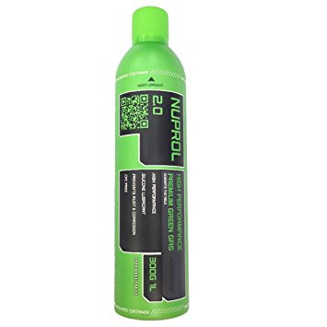
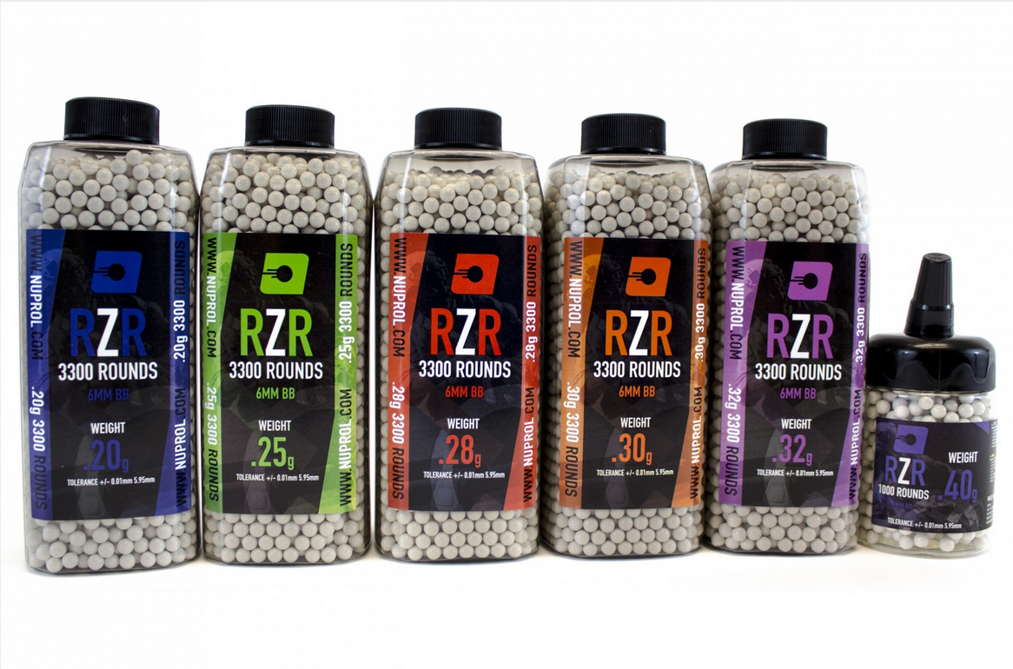
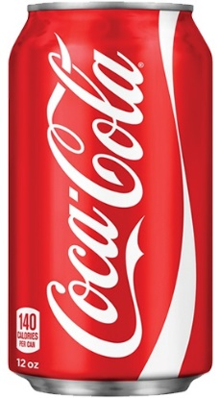
Energy Drinks £1.50 per can

